GREENHOUSE EFFECT

Earth’s atmosphere acts like a giant invisible blanket that keeps temperatures on our planet’s surface within a range that supports life. Within the atmosphere, greenhouse gases trap some of the energy leaving the Earth’s surface to help maintain these warm temperatures. The maintenance of Earth’s temperatures by these atmospheric gases is called the greenhouse effect.

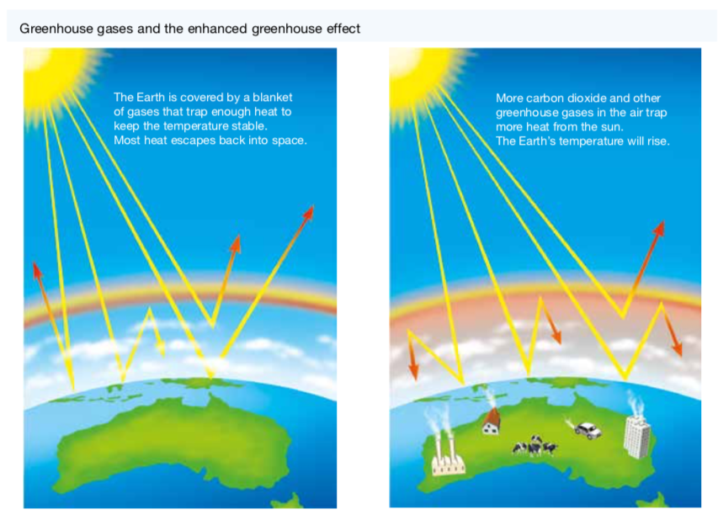

Global Warming

Global temperatures have been increasing and are expected to continue to increase at an accelerated rate. The rising temperature of Earth is known as global warming. This may result in melting icecaps, rising sea levels, increased coastal flooding, unusual weather patterns and ocean currents, and threats to the survival of some living things.

The following diagram summarises the sources of greenhouse gases.

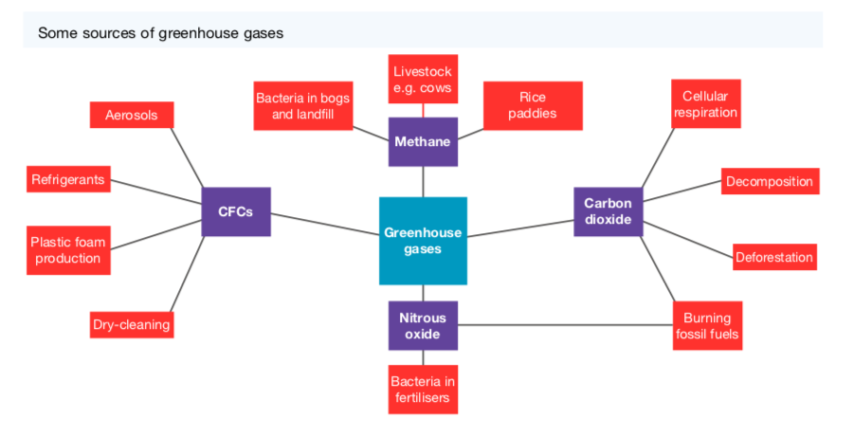
Sources of Greenhouse Gases

• Fossil Fuels

Scientists assert that our increased and growing dependence on fossil fuels since the Industrial Revolution of the nineteenth century is a major cause of global warming. They argue that burning fossil fuels (such as coal and oil) has resulted in increased levels of greenhouse gases (such as nitrous oxide and carbon dioxide) in our atmosphere that are trapping heat, causing the atmosphere to heat up.

This is referred to as the enhanced greenhouse effect.

• Grazing animals

Animals such as cattle and sheep produce large amounts of methane as a waste product.

• Bacteria

Methane is another powerful greenhouse gas and is also produced by the action of bacteria that live in landfills and soils used for crop production.

Much of the nitrous oxide in the atmosphere is produced by the action of bacteria on fertilised soil and the urine of grazing animals.

• Photosynthesis and Cellular Respiration

CO₂ is taken from the atmosphere during photosynthesis and released back during cellular respiration.

This suggests that if producers (plants) are reduced in number or removed from the atmosphere, there will be less carbon dioxide removed from the atmosphere, resulting in an overall increase in this gas.

• Decomposition and Fossil Fuels

Carbon dioxide is also released from dead and non-living parts of ecosystems.

When these fossil fuels are burned, carbon dioxide is released back into the atmosphere.

• Ozone

Ozone (O₃) in the lower atmosphere is also a significant contributor to the enhanced greenhouse effect.

Although ozone occurs naturally, it is also produced by a photochemical reaction that takes place when sunlight falls on emissions from motor vehicles, power stations and bushfires.

Evidence of Global Warming

• Increasing CO₂ Levels

Scientists have used ice cores to track the air temperature and concentration of carbon dioxide near the Earth’s surface in the past. The graphs below show how these have changed over the 420 000 years leading up to the year 2000.

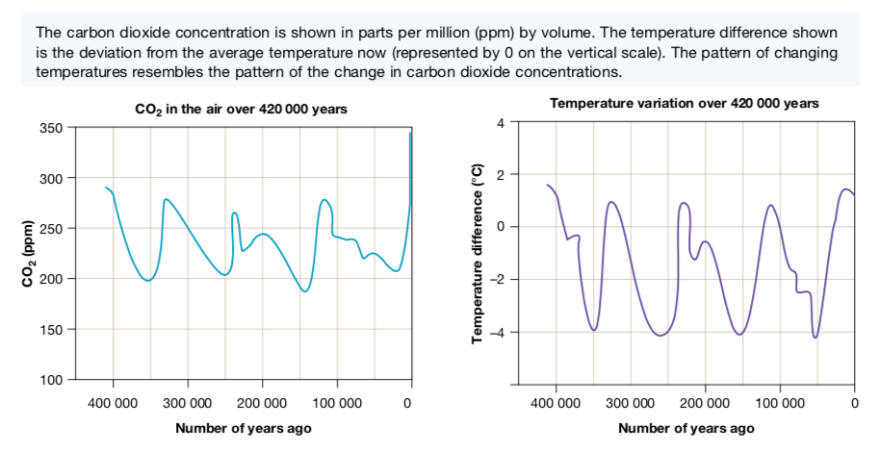

During the current decade the concentration of CO₂ has risen to approximately 400 parts
per million. There appears to be no significant change in global temperature cycles.

However, the graph below shows that since the Industrial Revolution, there has been a dramatic change in the trend of carbon dioxide in the atmosphere.

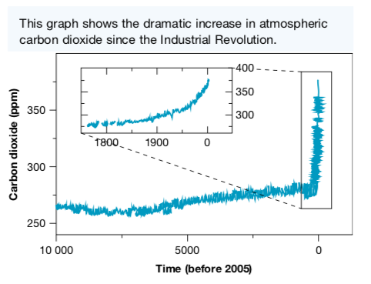

• Climate Models

Meteorologists and other scientists use computer modelling to make predictions about
climate change and the possible consequences.

The computer programmes used to model climate change simulate the circulation of air in the atmosphere and water in the oceans. An immense amount of data collected from the atmosphere, ocean and land surface is used, together with mathematical equations that describe the circulation.

• Global Temperature

It is generally agreed that during the next 100 years, the average global temperature could increase by between 1 °C and 4 °C. Computer modelling suggests that the global temperature will not increase evenly across the continents.

According to CSIRO in Australia, temperatures could increase by up to 2 °C by 2030 and up to 6 °C by 2070. As a consequence, there will be:

• more hot days and fewer cold days
• an increase in rainfall in the north-east and a decrease in the south
• more bushfires
• more destructive tropical cyclones

• Rising Sea Levels

According to tide-gauge records, the average global sea level has increased by between 10 cm and 20 cm during the past 100 years.

Sea levels are expected to rise further due to:

• the warming ocean water and its resulting thermal expansion
• the melting of glaciers, the polar ice- caps and the ice sheets of Greenland and Antarctica.

According to NASA, sea ice in the Arctic is melting at the rate of 9 % every ten years. Of the world’s 88 glaciers, 84 are receding due to melting ice.

Rising sea levels are likely to cause the flooding of low-lying islands and coastal regions.

• Frozen Soil

Much of the soil on or below the surface of very high mountains in the polar regions is permanently frozen - called permafrost.

This soil is likely to gradually thaw out as global air temperatures increase, potentially releasing large quantities of CO₂ and methane will be released into the atmosphere. This would increase the rate of climate change.

